Assignment-2
Task – 1
Description: Use Google Gemini in Colab to write a function that reads a CSV file and calculates mean, min, max.
Prompt : write a function that reads a CSV file and calculates mean, min, max.

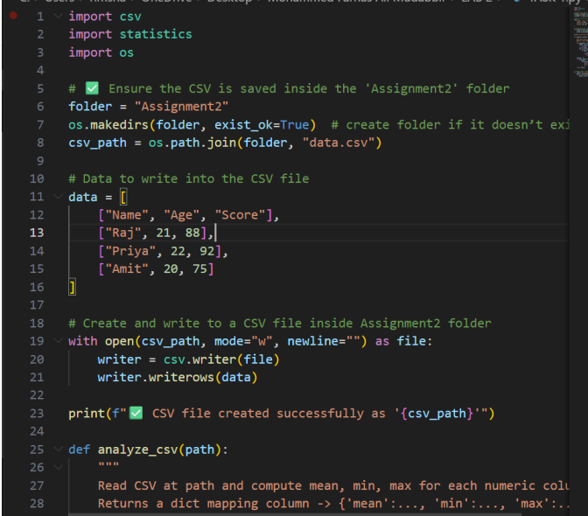
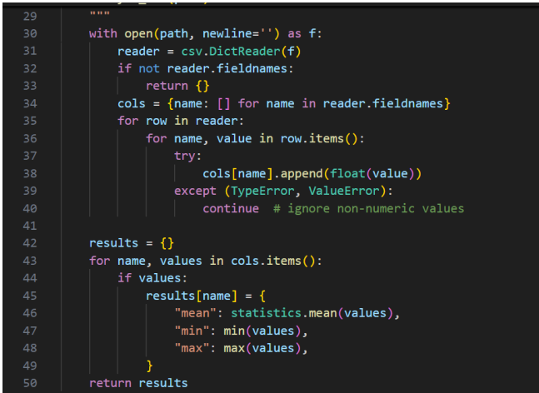
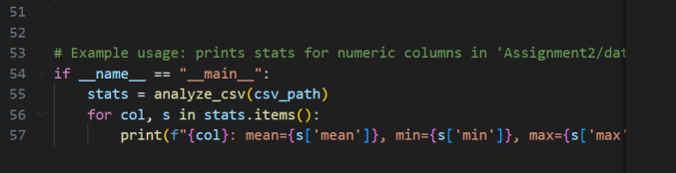

Expected Output: Functional code with output and screenshot
Practical Output:

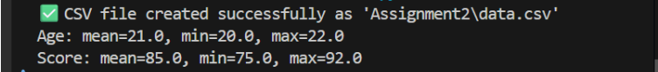

Task -2
Description: Compare Gemini and Copilot outputs for a palindrome check function.
Prompt: write a user input palindrome function
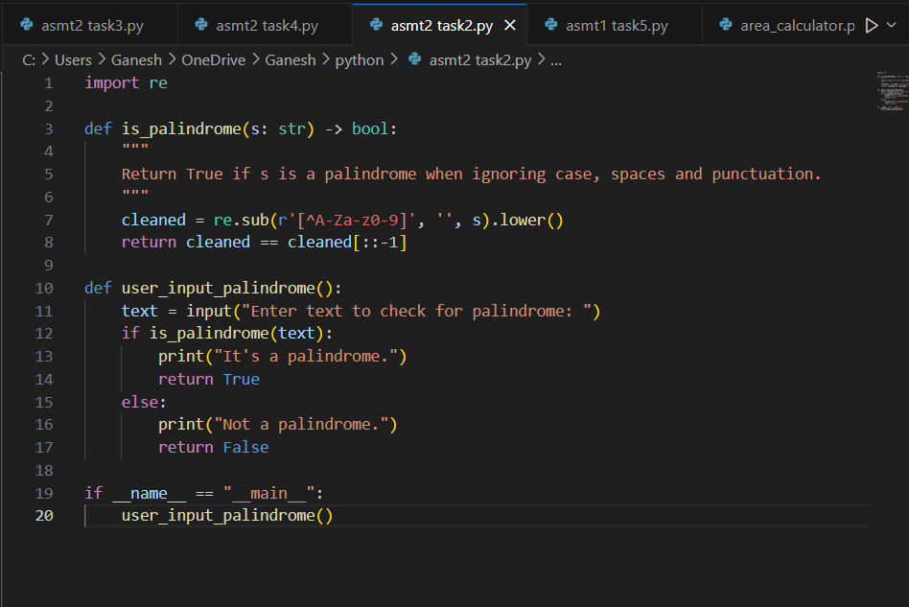

Expected Output: Side-by-side comparison and observations
Practical Output:
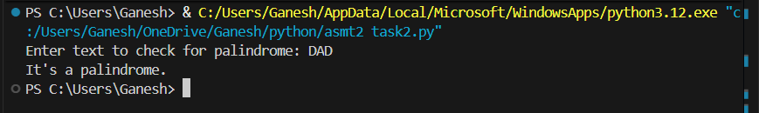

Google colab:
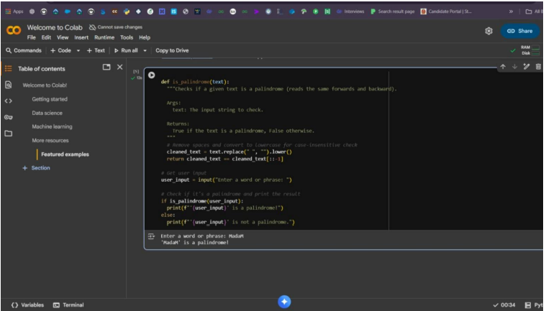

Task – 3
Description: Detailed explanation with code snippet
Prompt: Write a user input python function to calculate area of various shape

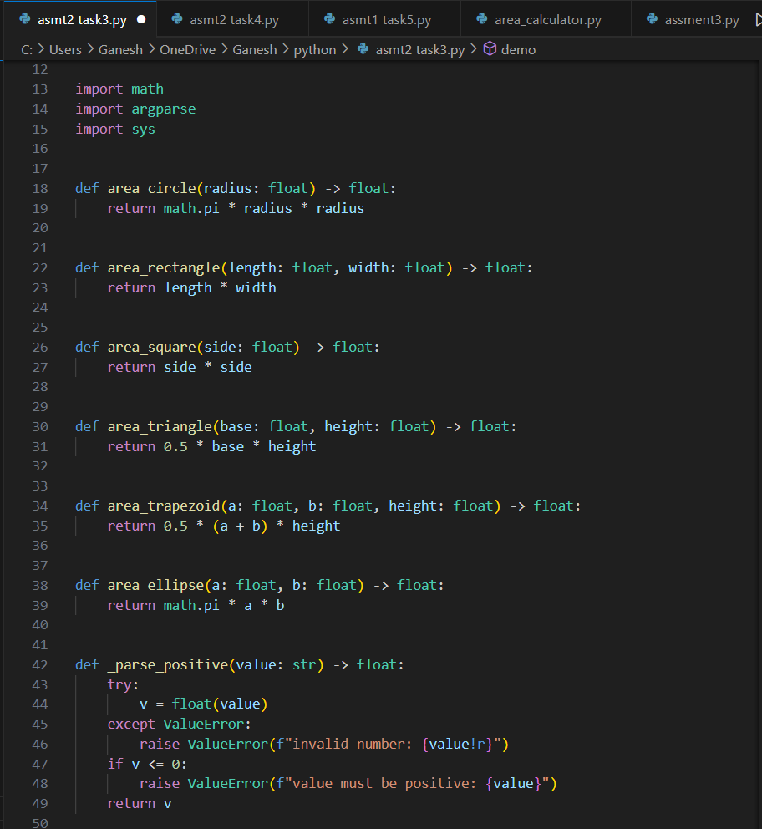

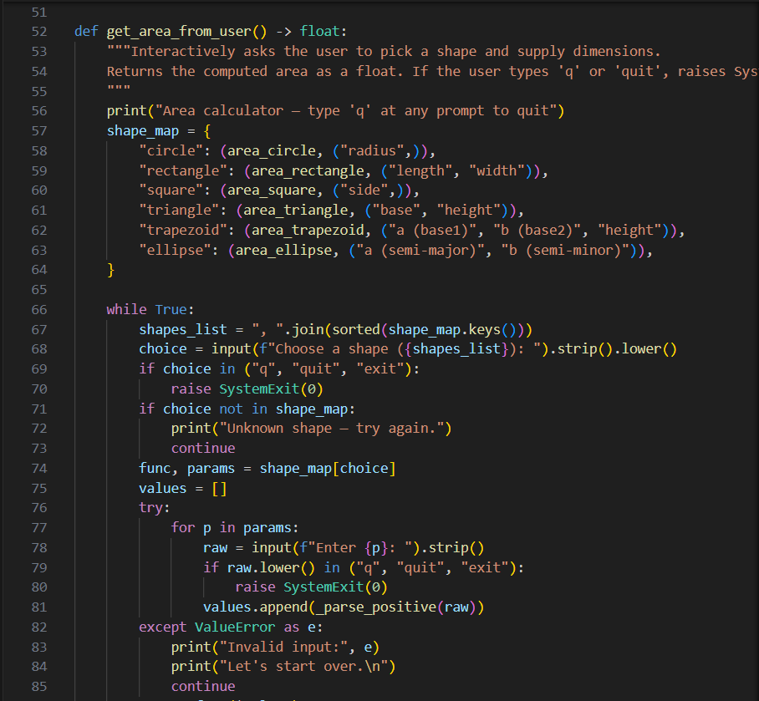

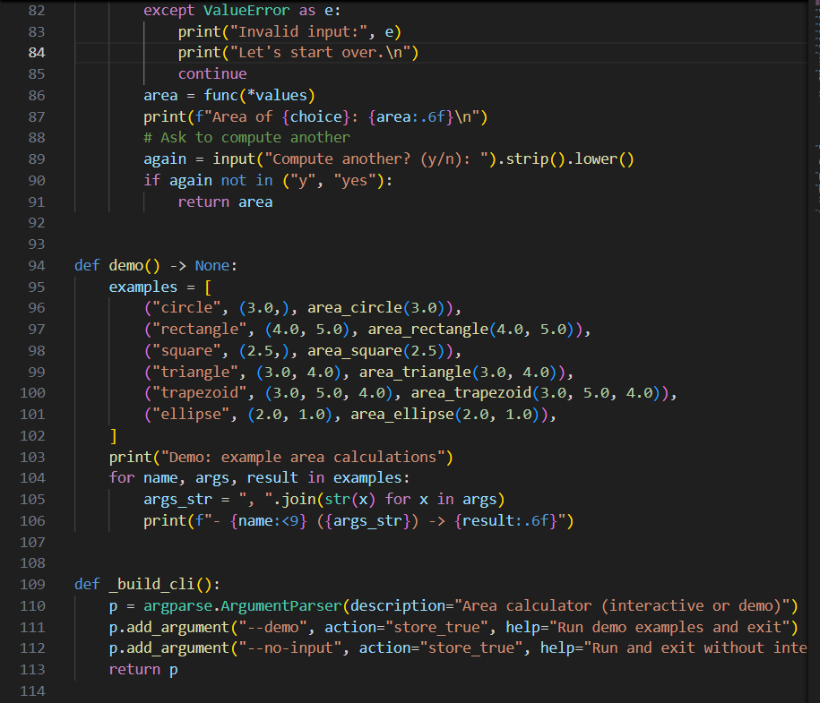
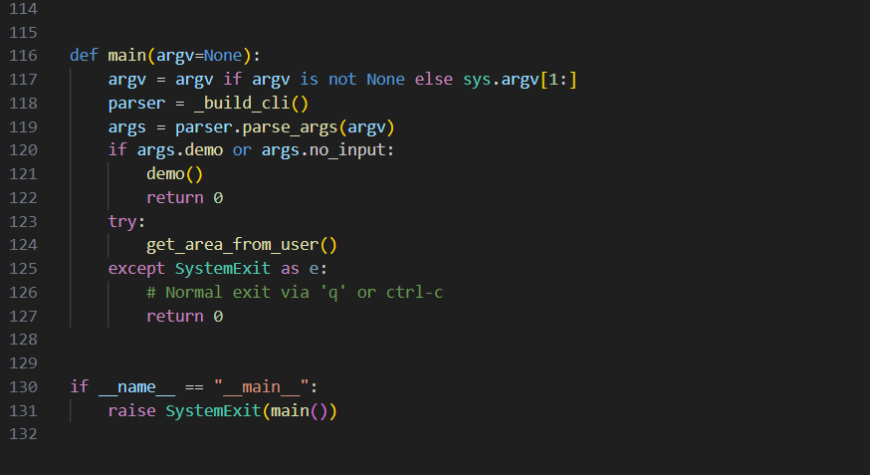
Expected Output: Detailed explanation with code snippet
Practical Output:

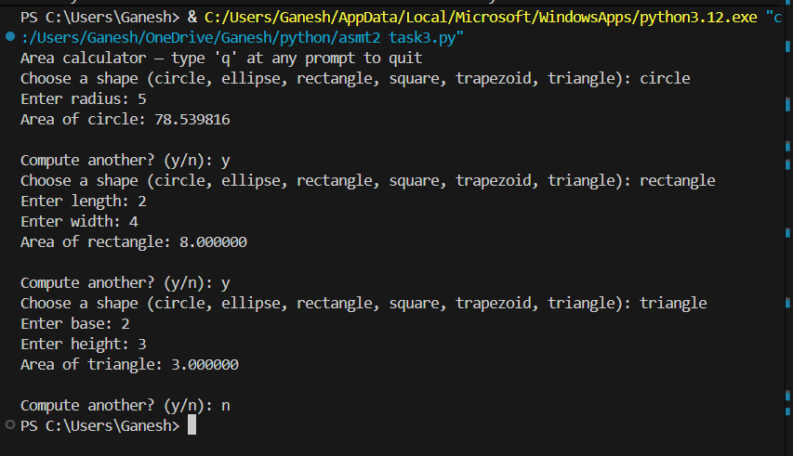

Task – 4
Description: Install and configure Cursor AI. Use it to generate a Python function (e.g., sum of squares).
Prompt: Generate a user input python function to calculate sum of square

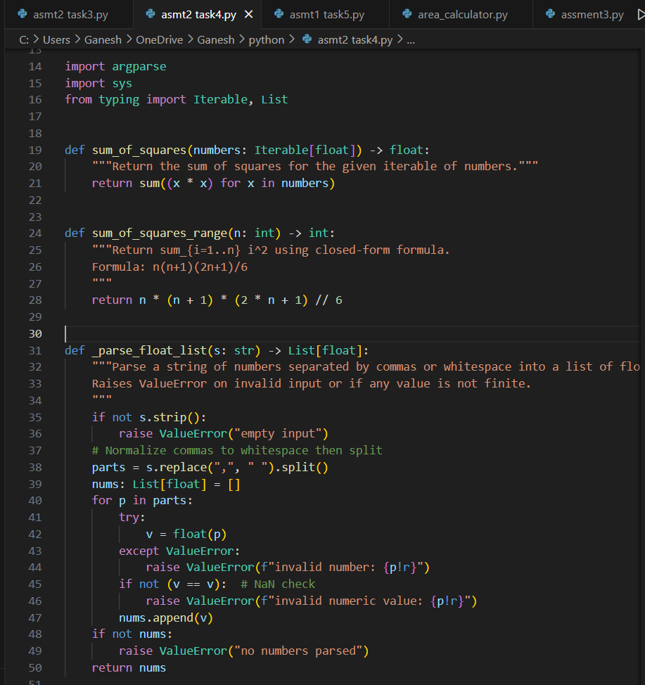
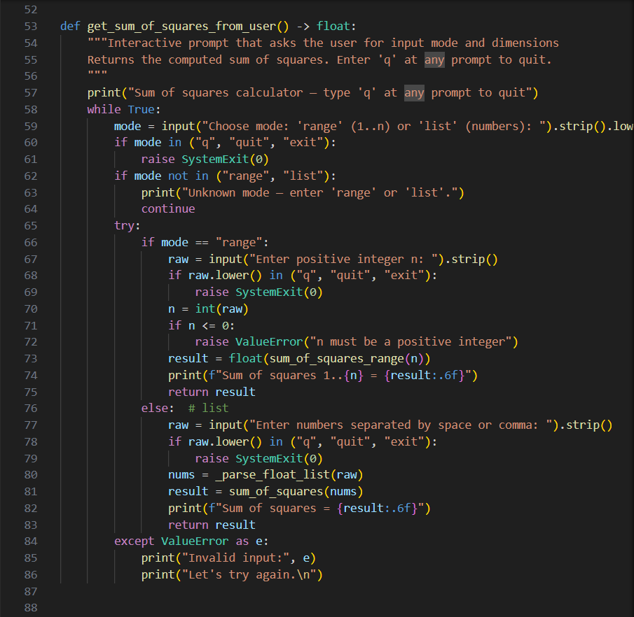

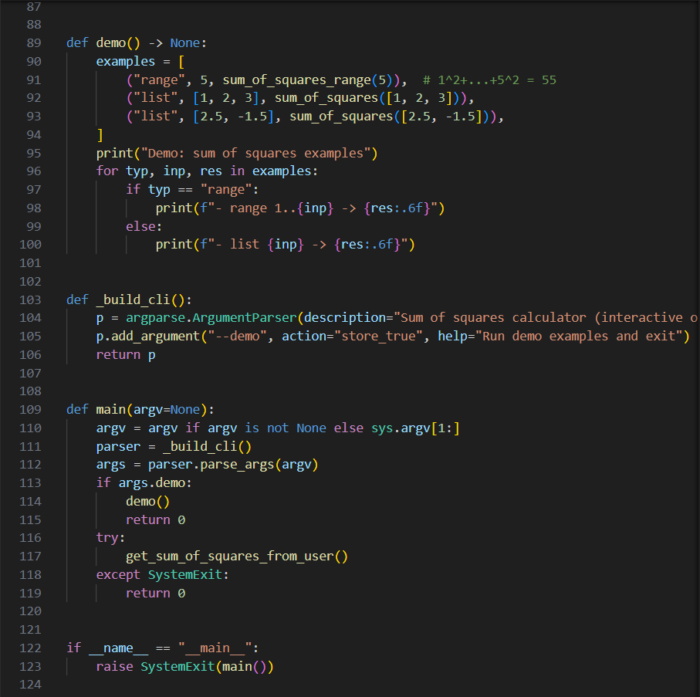

Expected Output: Screenshots of working environments with few prompts to generate python code
Practical Output:

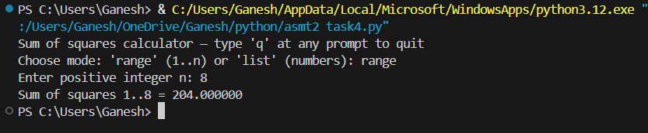

Task – 5
Description: Student need to write code to calculate sum of add number and even numbers in the list
Prompt: write code to calculate sum of add number and even numbers in the list
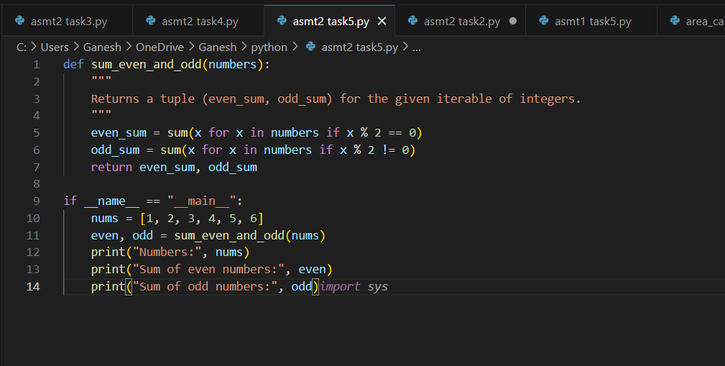

Expected Output: Refactored code written by student with improved logic
Practical Output:

